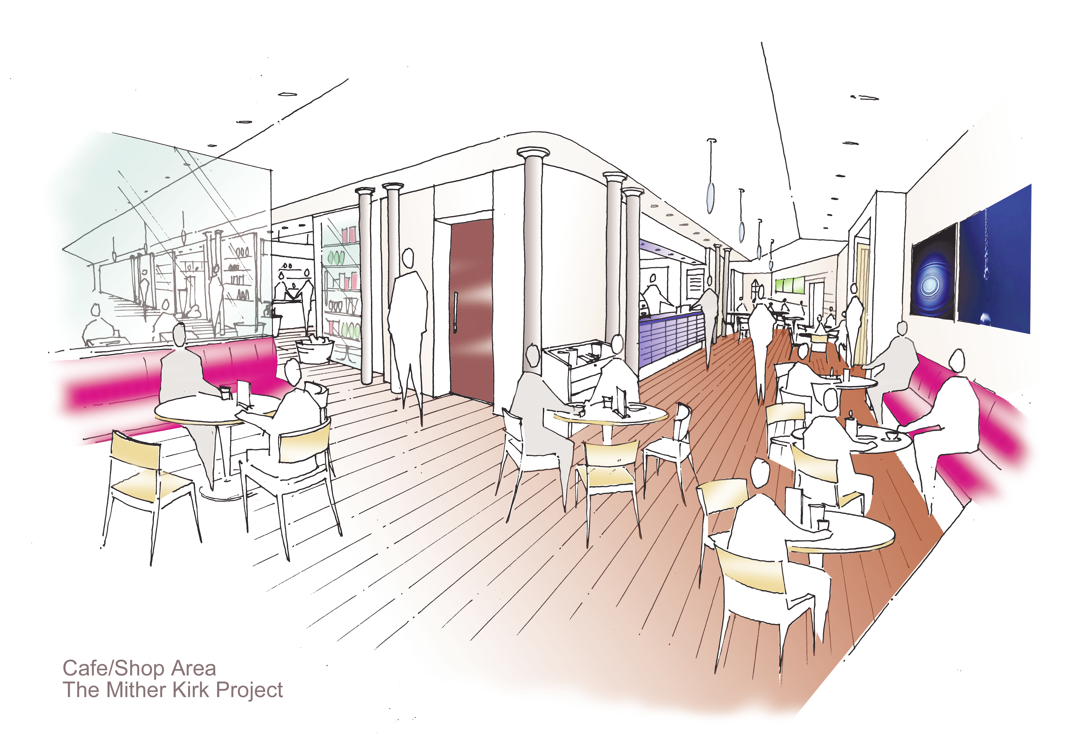



The OpenSpace Trust is altering the east end of the Kirk of St Nicholas
- Aberdeen’s Mither Kirk –
to create a new and exciting community facility in the very heart of the city.
To find out more visit www.openspacetrust.org.uk

What have we done?

Apart from the archaeological dig, in 2010-2011 a major contract saw the building made wind and water tight. This involved a new roof, all glass replaced, repaired or conserved, the pointing and rainwater goods replaced.

What will be in the building?

There will be a focus on heritage. Displays will tell the development of the building and the city and tell the story of the people of Aberdeen. In addition the City Archive will have a presence with facilities to access other archives electronically and some genealogy. A café and other meeting places will be included. St Mary’s Chapel will be restored and available.
The OpenSpace Trust — Membership Application
I wish to apply for Full / Associate * membership
* delete as appropriate
Title ………. First Name ………………………………. Surname …………………………………………………
Address …………………………………………………..
………………………………………………………………………………………………………………………………
Postcode ……………Telephone ………………………
Email ………………………………………………………
I wish to receive information electronically
The annual membership fees are:
Full Member £10
Student / unwaged / Full Member £5
Associate Member £5
Charity Member £15, 5 yrs £60, 10 yrs £100
Corporate / Institutional Member for 10 years £1,000
Cheques payable to The OpenSpace Trust
As a member I agree to computer processing of the personal information above for the purposes of carrying out the business of The OpenSpace Trust. This information must not be disclosed to others without my written consent.

Signature ………………………………Date ……………
Please Gift Aid my donations



Become a Member of The OpenSpace Trust

Full Membership is open to those living in Aberdeen or Aberdeenshire. It gives the right to attend the AGM, vote and stand for Board membership.

Associate Membership is open to those who support our aims but who are not eligible to have voting rights as described above.
Please complete the application form overleaf and post it, together with payment to:

The OpenSpace Trust
The Lodge, Kirk of St Nicholas, Back Wynd,
Aberdeen AB10 1JZ
Tel: 01224-643580
Email: arthurjwinfield@yahoo.com

The OpenSpace Trust is a guarantee company under
Company Number SC292077
Scottish Charity under Scottish Charity Number SC036920
Registered Office: 12-16 Albyn Place, Aberdeen AB10 1PS

OpenSpace is a vibrant new development located at the heart of the City Centre between Union Street and Schoolhill
next to the St Nicholas Centre

It is an exciting blend of restoration and the creation of new spaces open to all. Before the redevelopment of the east end of the Kirk of St Nicholas building could begin there was an archaeological dig lasting nearly a year. This uncovered many unusual finds, including an 11th century apse (the oldest visible wall and floor in Aberdeen) and a medieval staircase. These will be incorporated into the building and some other artefacts will be displayed.
The redeveloped building will have improved physical and sensory access to enable visitors to enjoy and appreciate both the new facilities and experience the heritage of the building.
The OpenSpace Trust is aware of our obligation to retain and conserve many of the original features in this Category A Listed building. These will include the magnificent stained glass (some thought to be more than 150 years old), the moulded ceiling and the historic St Mary’s Chapel dating from the 15th century.

Membership

Application

Form

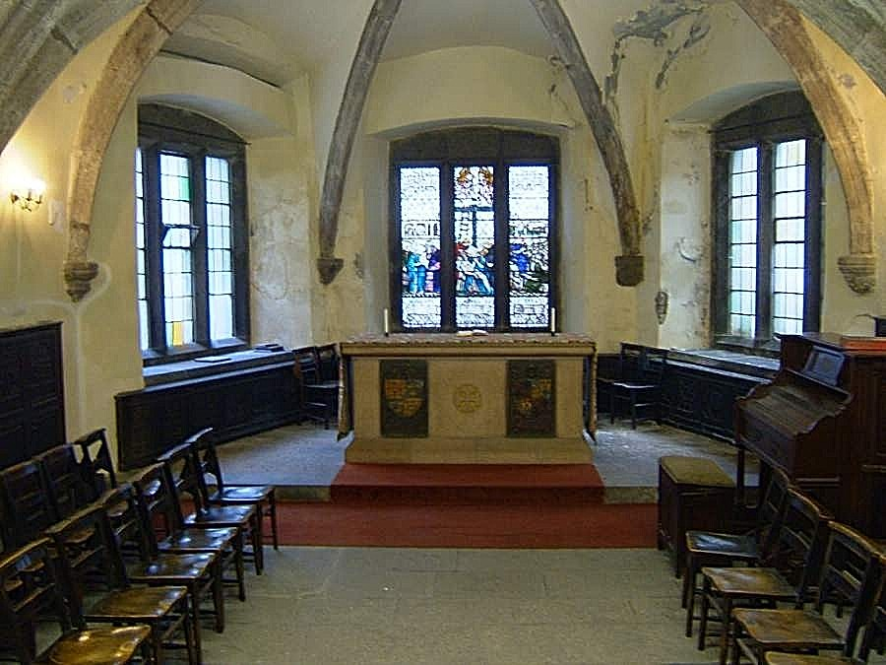

The OpenSpace Trust,
The Lodge, Kirk of St Nicholas, Back Wynd, Aberdeen AB10 1JZ
Tel: 01224-643580

The OpenSpace Trust is a guarantee company under Company Number SC292077
Scottish Charity under Scottish Charity Number SC036920

